Foam Roller Exercises (Lower Body)

The following Foam Roller Exercises are designed to release muscle tension and improve the flexibility of specific muscles of the pelvis, thigh and lower leg. When performed correctly, these Foam Roller Exercises can be used for effective self massage or muscle release techniques, simulating the effects of a sports massage.
You should discuss the suitability of these exercises with Mark or Julie prior to beginning them. Generally, they should only be performed provided they do not cause or increase pain.

Foam Roller Exercises (Lower Body)
The following foam roller exercises should generally be performed 1 - 3 times per day provided they do not cause or increase pain. Initially, they should be performed gently, infrequently and on a soft surface to allow the body time to get used to the exercise. As flexibility improves, these Foam Roller Exercises can be progressed by performing them on harder surfaces or by gradually increasing the duration or frequency of the exercises provided they do not cause or increase pain.

Gluteal Release

This foam roller exercise is designed to improve gluteal (buttock) flexibility.

Place the foam roller under your gluteals (buttock) as demonstrated (figure 1). Using your arms and leg, slowly move your body forward and backwards allowing the foam roller to massage your buttock region. Breathe normally keeping your legs relaxed. Repeat this process for 15 – 90 seconds provided it is comfortable and does not cause pain. This exercise can be performed with your lower leg straight or bent and with your upper arm on the ground in front of or behind your body.
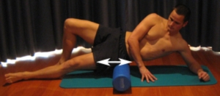
Figure 1 – Gluteal Release

Hip Flexor Release
This foam roller exercise is designed to improve hip flexor flexibility.
Place the foam roller under your hip flexors (front of your upper thigh and pelvis) as demonstrated (figure 2). Using your arms, slowly move your body forward and backwards allowing the foam roller to massage the front of your hip and pelvis. Breathe normally keeping your legs and pelvis relaxed. Repeat this process for 15 – 90 seconds provided it is comfortable and does not cause pain. This exercise can be performed on your forearms or hands and with both legs off the ground and the leg that is not being massaged in contact with the ground (via the toes).
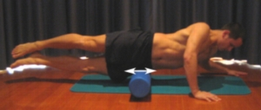
Figure 2 – Hip Flexor Release

ITB Release
This foam roller exercise is designed to improve ITB flexibility. It can be extremely effective in treating common knee injuries such as ITB Friction Syndrome and Patellofemoral Pain Syndrome.
Place the foam roller under your ITB (outer thigh) as demonstrated (figure 3). Using your arms, slowly move your body up and down the roller allowing it to massage the outer thigh. Breathe normally keeping your leg relaxed. Repeat this process for 15 – 90 seconds provided it is comfortable and does not cause pain. This exercise can be performed with both legs off the ground as demonstrated (figure 3) or with the upper leg in contact with the ground (via the foot) in front of or behind the lower leg.
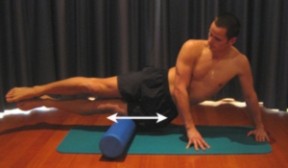
Figure 3 – ITB Release
