8 Minute Routine

- Squat / Raisers Strength
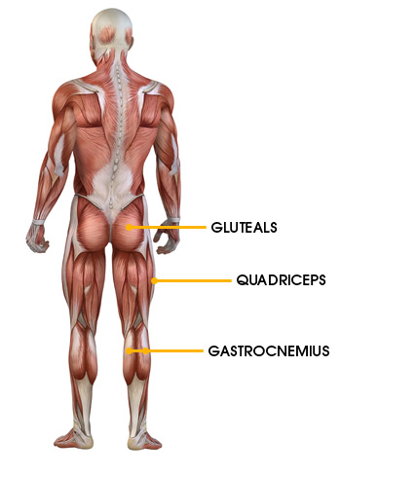
The 1st part of the 8 minute routine is a very important for general leg strengthening. It targets hip stability and the core, also important for knee tracking issues. Make sure the knee cap (patella) tracks in line with the 2nd toe of the foot.

- Push ups
The 2nd part of the 8 minute routine is an important exercise for upper strength. It targets the core as well as the shoulders and arms.
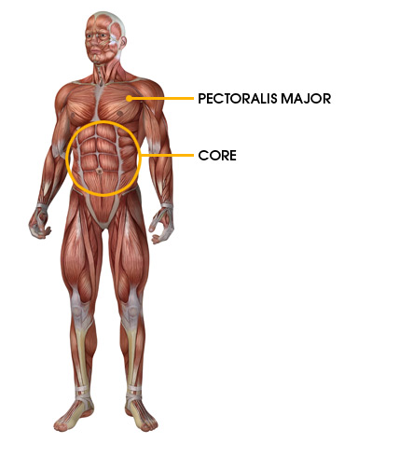
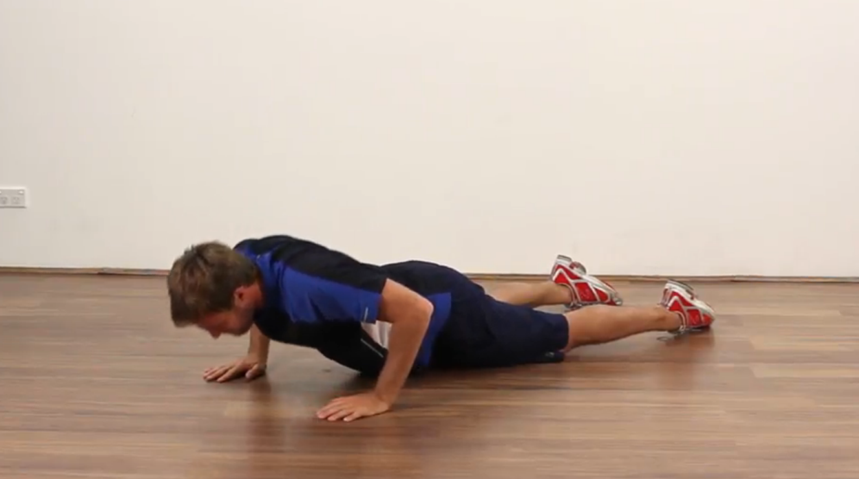
- Bridge Progressions
The 3rd part of the 8 minute routine is a great strengthening exercise on the gluteal and hamstring groups and gets them working together. An area of the body that is often weak.
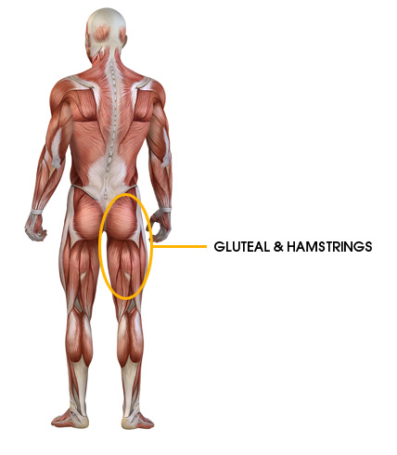

- 4. Side Bridge
The 4th part of the 8 minute routine is a very important exercise to strengthen the abdominals, shoulders and the spinal support muscles.
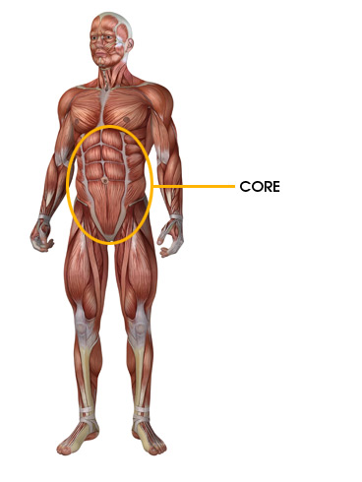
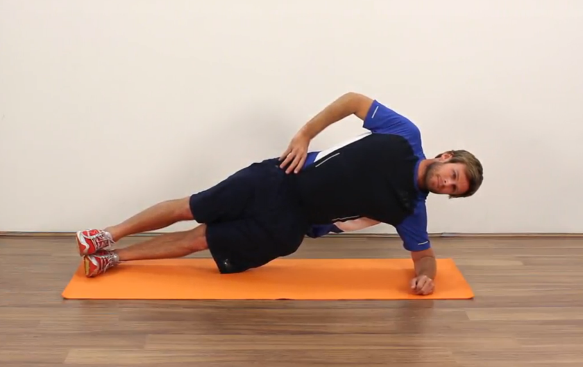
- Cat Stretch
The 5th part of the 8 minute routine mobilises the whole spine.
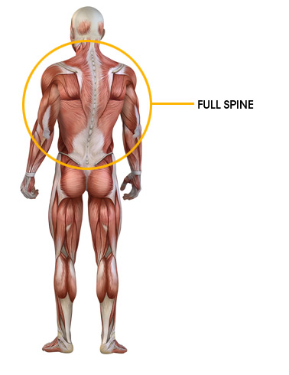
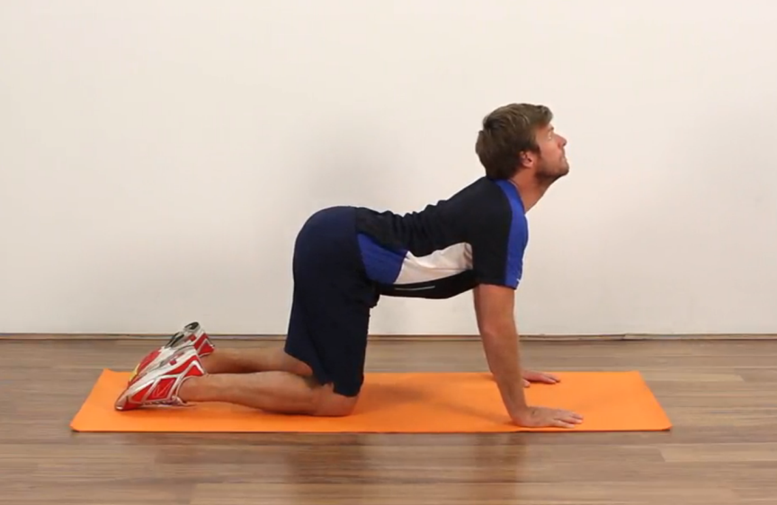

- Gluteal Stretch
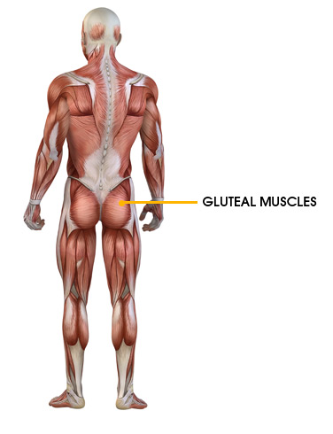
The 6th part of the 8 minute routine stretches the gluteal muscle group which is often tight.

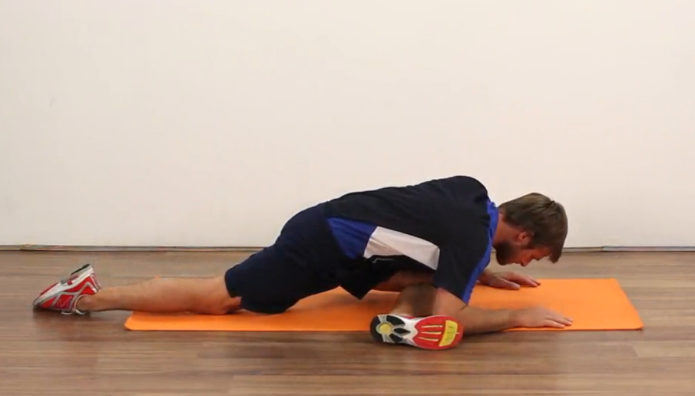

- Brugger
The 7th part of the 8 minute routine is probably the most important exercise to help good posture and maintain a correct spinal position.
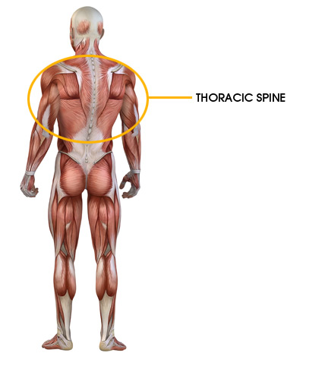

- Psoas
The final part of the 8 minute routine stretches the psoas muscle which is the main muscle of the hip flexor group. It will help with a longer stride length by increasing hip mobility.