

**S.I. Exercises**

***Knee to Chest***

Lie on the floor, table or bed. Rest your left leg on the floor. Bend the right leg and wrap your hands around your knee. Pull the bent leg toward your chest. Hold for 30 seconds, then relax and repeat with opposite leg.



***Knee to Opposite Shoulder***

Lie on the floor, table or bed. Rest your left leg on the floor. Bend the right leg and wrap your hands around your knee. Pull the bent leg toward your left shoulder. Hold for 30 seconds, then relax and repeat with opposite leg.

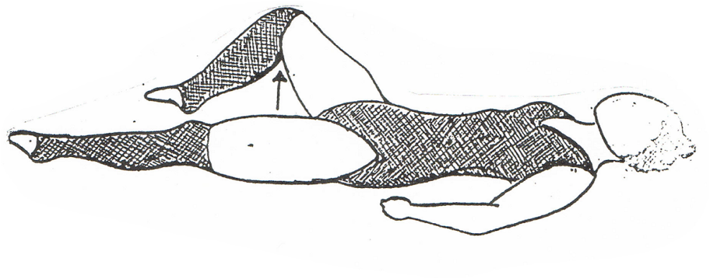  
***Drop leg out 90 degrees from Body***Lie on the floor, table or bed. Rest your left leg on the floor and drop your right leg out 90 degrees from your body. Hold for 30 seconds and repeat with opposite leg.